Meeting Minutes
Queen Mary Elementary School PAC Meeting
December 5, 2023 7:30pm
Virtual
Executive

Chair: Laura Atkins Non-voting Member: Elyssa Derban, Principal
Vice Chair: Vacant Vancouver District PAC (DPAC) Representative: Sandra Nelson
Secretary: Sandra Nelson Members at Large: Jasmine Ma, Amber Sessions
Treasurer: Raymond Wong

In Attendance:
Laura Atkins, Jasmine Ma, Sandra Nelson, Raymond Wong, Elyssa Derban, Ehsan, Heidi Neinaber, Nazy Alborz, Elham Mehrdad, Nirvana Kiarostami, Holly Liu, Ahmed Abdulrazak, Natalia Kravchenko , Escobar Family, Kuljit Sajjan, Angie Tong

Meeting
- Welcome and Land and Territory Acknowledgement (Laura)

- Review of Meeting Etiquette as per BCCPAC (Laura)
- BCCPAC advises that all PACs should agree to ground rules

- Agenda Approval
- Motion: Jasmine Ma
- Second: Kuljit Sajjan
Carried (1 opposed – Ehsan)

- November 2023 meeting minutes approval
- Motion: Jasmine Ma
- Second: Raymond Wong
Carried

- Principal’s Report (Elyssa Derban)
- Review of events since last PAC Meeting:
  - PAC Movie night
  - Nov.24 – Pro-D with indigenous focus. Really excellent day
  - Last Friday – written learning update #1 came home.
  - Nov.30 – Elyssa provided parents/caregivers of QM the Ministry of Education update on what the learning update contains
  - Yesterday – Saleema Noon parent workshop
- Coming up:
  - Saleema Noon for students Dec.7/8
  - Craft and Games Fair Dec.15
  - Lots happening class-wise. Grade 7s been invited to Lord Byng for a presentation.
  - Holiday Sing-a-Long coming up
- Comment from attendee – last year at Sing-a-long, it was divided by division so that it didn’t go over capacity

- Treasurer’s Report (Raymond Wong)
- Accounts are quite healthy in general
- Attendee question: what determines a healthy account? Laura: Generally the same amount comes in each year to our PAC and roughly the same expenses. But the past year by doing the new Craft and Movie Night last June, we were able to increase the money in our account and so have been able to increase the teacher’s spending amount that we provide
- Can sustain our requirements for the year with our accounts. So no urgent need to fundraise
- Ahmed – is there a policy or is it a tradition on what we spend things on? Laura – we decide together as a PAC as what we spend on; what matters to us as a PAC group

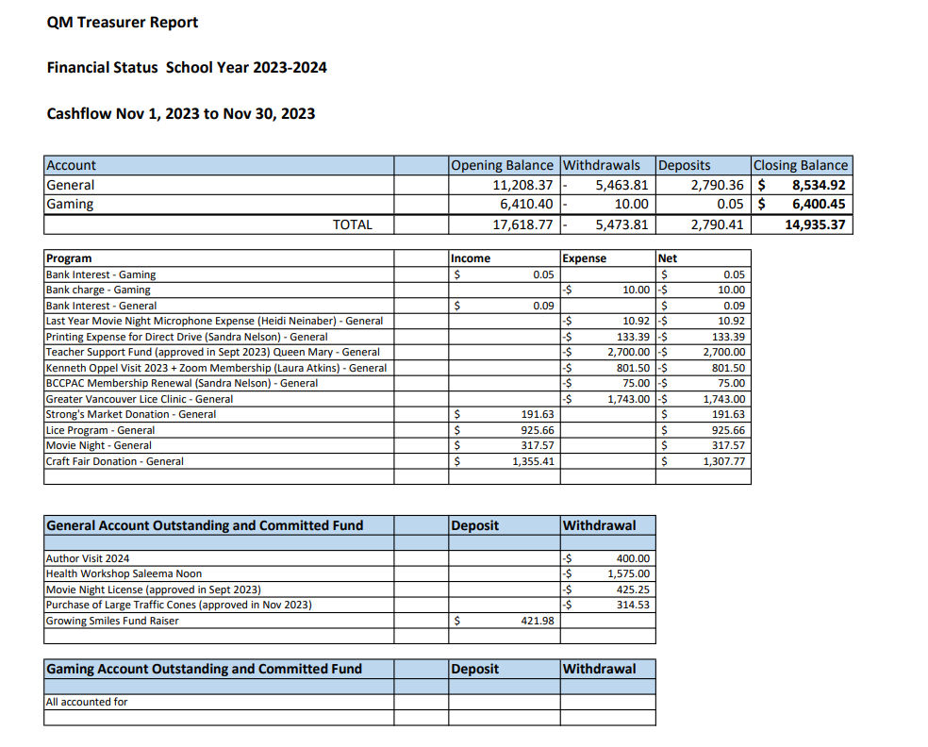
- Fundraiser pick up reminders (Laura)
  - Growing smiles pick-up Dec.6 at pick-up and Dec.7 at drop off and pick-up
  - Purdy’s Dec.13
- Craft and Games Fair (Laura)
- Cake donations – 11 people signed up. We need about 70 cakes, cookies, cupcakes, etc. please email meghanliving@mac.com to donate a cake
- Donations – we tried something new! Have a one-stop donation this year. Just under $3000 ini donations so far. Every child will be able to participate even if you don’t donate. Thank you to everyone who has donated
- A question for Elyssa: what will the schedule be for craft fair visits? Plan is for primary years in the morning and intermediate years in the afternoon
- Volunteers – doing well for volunteers. If want more than one timeslot contact Laura. Need more for 3-5 and clean-up. If not enough volunteers for end of the day we will cancel the 3-5 portion (were trying something new to extend it later)
- Games and Stations: see slide

- Multicultural Celebration Update/Multicultural Celebration funding discussion (Jasmine Ma)
- Time decided Feb.13
- If still interested to join, can contact Jasmine
- A new event, so like any new event, it is a challenge to start up.
- Any performance approval will need to be approved by Laura, Elyssa and Jasmine
- Timing – Fair will be 2 hours long from 6:00-8:00
- Need to allow participants to travel from booth to booth
- Need to abide by fire and safety laws and gym capacity
- What are hopes for this event and how to use resources wisely? Open discussion followed:
  - Elyssa: the PAC is ours and she acts as advisor and she also has role to manage evening events and commit her time. She keeps in mind, through experience, that any event needs to be both equitable and sustainable. It shouldn’t be a barrier to share their culture, so should be sustainable. Shouldn’t be so elaborate that parents don’t want to take it on in future years. Other aspect of sustainability - PAC supports school community - this is a beautiful event but shouldn’t be a costly event. Equitable – no barriers and everyone has the option to participate.
  - Ehsan: saw a lot of passion when he attended the meeting with Jasmine. They have been spreading the word. Thought a good opportunity to create a rich event with food, events, storytelling. A lot of ideas from Iranian community but it is a smaller size community. Would like a budget to be able to bring resources. If want to have an event we need to have some resources at hand.
  - Kuljit: she is one of the presenters at the event and volunteered because a lack of a Punjabi presence at the school so thought it would be helpful and educational. If it gets pretty big then would be unsustainable and wouldn’t be able to volunteer. She thought it would be a grassroots event and be a stepping stone and would like it kept smaller so don’t have to look for
  - Natalia – her community is smaller at QM. She can only share what Russian culture means to her and her daughter – personal experience. If expected to do some great presentations it would be challenging for her. She would like to keep it personal
  - Laura – unrealistic to not spend money on this. It would be appropriate to consider a budget and define what it is spent on. Hopes to relieve a burden to participating by providing some money.
    - Nazy – thinks performances would take it to a different level
    - Heidi – Is money necessary? If some people have grander ideas than others then it is not equitable. She is opposed to bringing in dancers, for example, that aren’t part of the QM community
    - Nirvana – her understanding is that whatever is decided upon would be shared evenly amongst the groups participating
    - Laura – could do an ad hoc meeting to discuss, and also recommended by DPAC is to be thoughtful on big decisions. She will talk with Elyssa and Jasmine whether a meeting needs to occur before the next PAC meeting

- DPAC Rep Report (Sandra Nelson)
- DPAC report not given during meeting due to time constraints. Instead providing update in meeting minutes
- Here is an overview of the last DPAC General Meeting that occurred on November 23
  - Tyee PAC gave a presentation on Kindergarten Choice Program Waitlist Process
  - Update provided on SLO program
  - DPAC Working Group presentations were given by the following groups. They are run by parent volunteers. Any parent/caregiver can join a Working Group if interested.
    - Health & Safety Working Group
    - Inclusive Education
    - Food Framework
    - Facilities

- Parent Education Speaker Night 2024 (Sandra Nelson)
- Typically the PAC pays for a parent education night each year
- 2 possibilities so far:
      - Deborah MacNamara, PhD
        - Her website is macnamara.ca
        - Clinical counsellor, educator, professional speaker
        - 3 published books
        - Over 20 topics to choose from for her to speak about
        - She gave a talk to the parents at QM 3 years ago which was really well done (in Sandra’s opinion)
      - Screening of “Screenagers: Growing Up in the Digital Age” documentary +/- facilitated discussion afterwards
        - A parent suggested this as she has watched this documentary with her kids and found it really good
        - Screenagersmovie.com
        - Delaney Ruston, MD – primary care physician and documentary film-maker
- Attendees suggested other ideas:
  - Elyssa – Anxiety BC has presented to PACs in the past
  - Kuljit- consider Jesse Miller and Mediated Reality. Also had a talk on anxiety given by a local child psychologist in the past
  - Nazy – digital safety workshops for kids would be another option. Hearing good things about “safer school together” talk – workshop for internet safety for kids
  - Kuljit – Dr.Bethany Michel did a talk on Understanding Child Anxiety in June 2019

- After School Programs
- Update on Lights Up Musical Theatre after school program being offered in January: it’s full at 25 participants and currently have a waitlist
- WIZE Computing Academy is planning on having an after school program at QM for the winter as well. They are working with VSB room rentals currently to book a room at the school. Tentatively will be a “Lego WeDo” program for grades 1-3 and a “Minecraft Coding” class for grades 4-7. Once they finalize things, PAC will send out info on dates, cost and how to register.

- Babysitter course – will look into this for another Pro-D day

- Next Meeting – Tuesday, Jan.9 (virtual) – main focus will be Multi-cultural Fair

Meeting Adjourned
- 8:45pm

