Meeting Minutes
Queen Mary Elementary School PAC Meeting
February 20, 2024 7:30pm
Virtual
Executive

Chair: Sandra Nelson
Vice Chair: Amber Sessions
Vancouver District PAC (DPAC) Rep: Natalia Kravchenko
Secretary: Vacant
Treasurer: Raymond Wong
Members at Large: Jasmine Ma
Non-voting Members: Elyssa Derban, Principal, Laura Atkins, Past Chair

In Attendance:
Sandra Nelson, Amber Sessions, Raymond Wong, Jasmine Ma, Natalia Kravchenko, Elyssa Derban, Heidi Nienaber-Stephen, Laura Atkins, Nozomi Senga, Michelle Catlin, Minjeong Kim, Tory Brooks-Hill.

Meeting

- Land Acknowledgement and Welcome (Sandra Nelson)

- Round table Introductions

- Agenda Approval
- Two motions added by Sandra under Games and Movie Night.
- Educator Support Money motion added
- Scholarship money motion added.
- Agenda approved.
- January 2024 meeting minutes approval
Seeing no additions or corrections, the minutes were approved by Sandra.
Carried

- Ratification of people in new PAC Exec positions (Sandra Nelson)
- As per our PAC bylaws, the following people were appointed by the PAC Executive to the following roles:
- Sandra Nelson: Chair
- Amber Sessions: Vice-Chair
- Natalia Kravchenko: DPAC Representative
- Motions are required to approve their positions and for Sandra to gain signatory authority with the bank

- Motion to approve the appointment of Sandra Nelson as Chair of PAC and add her as a bank signatory.
- Motion: Heidi
- Seconded: Jasmine
- Discussion: None
- Carried

- Motion to approve the appointment of Amber Sessions as Vice-Chair of the PAC.
- Motion: Raymond
- Seconded: Natalia
- Discussion: none
- Carried

- Motion to approve the appointment of Natalia Kravchenko as DPAC representative.
- Motion: Heidi
- Seconded: Jasmine
- Discussion: none
- Carried

- Now that Sandra is no longer the PAC Secretary, we are seeking a Secretary. Please let Sandra know if you are interested. We require a Secretary to apply for a Gaming Grant.

- Reports

- Chair (Sandra Nelson)
  - Multicultural Celebration
  - A fantastic event that was well attended. Thank you to Jasmine for organizing and to all the volunteers (Sandra).
  - The booths were a real hit and attendees would have enjoyed even more time at the booths (Heidi).

  - Direct Drive update
-From 2022/23 Direct Drive: jerseys have arrived and are being used by the basketball teams currently
- Funds raised for this year allow us to move forward with Fish on the Fence (April 9-12).
- Direct Drive is still open.

  - After School Paid Programs at QM in Term 3
    - Wize Computing
    - Lights Up Musical Theatre
    - Looking into a choral program

  - Upcoming Events
    - Wednesday, Feb.28: Pink Shirt Day
    - March - applications can open for QM Alumnus Scholarship
    - April: Earth Day PAC Event organized by Laura
    - April or May:
      - Parent Education Evening with Deborah MacNamara
      - Screenagers movie screening
    - May:
      - May 9: Games and Movie Night
      - Teacher Appreciation Week
    - June:
      - Sports Day June 21
      - Grade 7 Leaving Ceremony

- Treasurer (Raymond Wong)

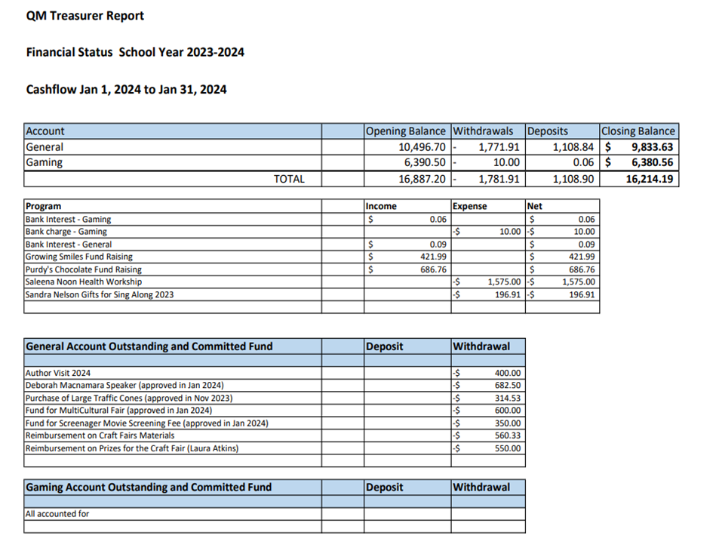
- There has been no major activity in PAC account since last meeting.
- Flagged that there is a $66 additional cost for the traffic cones delivery.

- Principal’s Report (Elyssa Derban)
  - Basketball season is wrapping up.
  - Student-led belonging assembly in January was well received.
  - Multi-cultural celebration was fantastic.
  - Communicating Student Learning occurred.
  - Black History Month was addressed at school and there was lots of good learning.
  - Grades 4 and 7 students are participating in the Student Learning Survey from the Provincial Government. Addresses how students feel about being at school and learning. Useful data for Principal and teachers.
  - Traffic / parking / intersections continue to be a safety issue. Principal is having a traffic expert come.
  - Three new, permanent supervision aids are starting.
  - Grade 4 and 7 students did the foundation skills assessment (literacy and numeracy). Of the 45 Grade 4 students who did the assessment, 91% were either on track or extending in literacy. 93% of students were on track or extending for math. Similarly good results for the 28 grade 7s who took the assessment.

- Scholarship Committee (Sandra Nelson)
  - Nirvana is the Chair of the Committee
  - If motion is put forward and carried for scholarship money to be used from general account then:
    - Beginning of March: applications sent to high schools and on PAC website
    - May 3: Deadline for application submissions
    - Committee will review submissions
    - Winner announced early June
  - Looking for 1-2 more volunteers for the committee
    - Role is to review applications and select winner

- DPAC (Sandra Nelson)
  - DPAC General Meeting held on Jan.25
    - Accessibility Committee of VSB
    - Facilities Working Group is working on 5 resolutions for DPAC
    - Tecumseh Elementary temporary relocation
    - Guest speaker: Valerie Jerome

- Other/New Business

- Pink Shirt Day (Sandra Nelson)
  - Pink Shirt Day (anti-bullying day) is Feb.28 (Wednesday)
  - PAC is selling some pink t-shirts on our website for $14 each (deadline Feb.26 at 10:00pm)
  - Pick-up of purchased t-shirts will be at the school on Tuesday, Feb.27 (at drop-off and pick-up)

- Coffee Mornings (Amber Sessions)
- PAC is planning a parent coffee morning (Friday morning at 9 am after drop off) which we hope will become a regular event.
- Coffee is being generously donated free of charge by Bean Around the World.
- First event will be March. Likely March 1.
- One parent flagged that Friday could be tough with Friday fitness but we agreed to give Fridays a try to see.

- Educator support money (Sandra Nelson)
- PAC typically provides QM teachers and resource teachers with monetary support twice/year (September and January)
- In the fall, $2700 was approved

🡪Motion to approve $2700 for QM educator support (teachers and resource teachers) from general account
  - Motion: Amber
  - Seconded: Jasmine
  - Discussion: Clarification of the amount
Carried

- QM Alumnus scholarship (Sandra Nelson)
- This cash award was established in 1996 to acknowledge all-round achievement by an alumnus of Queen Mary School upon acceptance into a full-time post-secondary education program
- In previous years this has been $1000

- Motion to approve $1000 from the PAC General Account for the QM Alumnus Scholarship
- Motion: Heidi
- Seconded: Amber
Carried

- Queen Alexandra Donation (Sandra Nelson)
- Our “sister” school is Queen Alexandra in East Vancouver.
- Typically, QM PAC provides a donation to QA each year
  - Past few years $750
- Can we help support them with a donation towards Saleema Noon program at their school?

- Motion to approve $750 from the general account to donate to Queen Alexandra School for their Saleema Noon Program
- Motion: Amber
- Seconded:
- Discussion: Laura reached out to Saleema Noon to see if they would qualify for discount. Laura advocates waiting until we hear back
Vote Tabled (delayed) until we know more

- Screenagers (Tory Brooks-Hill)
- Screenagers is a documentary film created by US physician Delaney Ruston.
- Explores the impact of screen use on children and offers solutions on how to manage
- Cost is $700 USD for a single screening
- Another option is for a 1 year license
  - Unlimited access to the film and curriculum
  - cost is $950 USD (~$1279)
- At last PAC meeting:
  - $350 approved towards Screenagers
  - Family contributing $500

- Motion to approve $450 from the general account to purchase the 1 year Screenagers license
- Discussion: Agreement to delay this motion to give school community more time to consider financial spend of PAC funds. Can we do a single screening and then upgrade? Can we preview the screening? Can we preview the education materials. Can we send the link to our full community?
Vote Tabled (delayed) until we get answers to those questions.

- Direct Drive (Sandra Nelson)
- The funds raised so far have been earmarked for the Fish on the Fence program April 9-12
- The school has technology needs (table provided by Ms.Derban)
- Ms. Derban described the technology needs to the PAC (see below).
- There was general sentiment that the PAC should support this.
- Laura will be managing the direct drive campaign for the remainder of the year
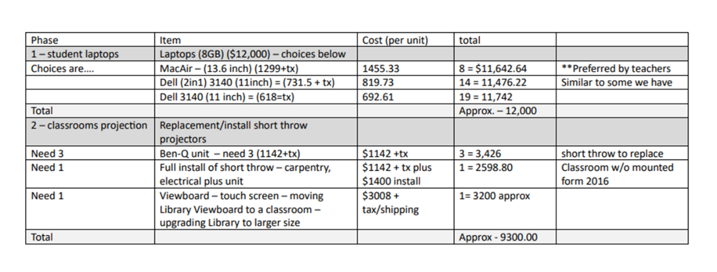
- Games and Movie Night (Laura Atkins)
- Thursday May 9, 2024. time tbd. Movie tbd.
- Decided to do this on a Thursday night.
- Sunset is 8:41pm.
- Ticket sales will start in April. Early Bird Pricing will be available for a limited time.
- Volunteers needed for all aspects of the event.
- A few changes this year…..

Motion: Approve $1800 + tax from the general account to pay for the screen and projector rental (includes labour).
Motion: Amber
Seconder: Jasmine
Carried

Motion: Approve up to $900 from the general account to cover the cost of the raffle prizes.
Motion: Heidi
Seconder: Amber
Carried

Next Meeting: Tuesday, March 12 at 6:45pm via Zoom

Time of Meeting Adjournment: 9:10 pm

