Meeting Minutes
Queen Mary Elementary School PAC General Meeting
Tuesday, March 12, 2024 6:45pm
Virtual
Executive

Chair: Sandra Nelson
Past Chair: Laura Atkins
Vice Chair: Amber Sessions
Secretary: Yimin Yuan
Treasurer: Raymond Wong
Vancouver District PAC (DPAC) Representative: Natalia Kravchenko
Members at Large: Jasmine Ma, Laura Atkins
Non-voting Member: Elyssa Derban, Principal

In Attendance:
Sandra Nelson
Natalia Kravchenko
Valentina Lurye
Raymond Wong
Nozomi Senga
Elyssa Derban
Joyce Frederikson
Heidi Neinaber
Erin Schwabe-Fry
Minjeong Kim
Michelle Catlin
Yimin Yuan
Yue Ma

Meeting

- Land Acknowledgement (Sandra)

- Introductions – round table

- Agenda Approval

  - Seeing no additions or corrections, the agenda was approved by Sandra

- February minutes approval – Seeing no additions or corrections, the minutes were approved by Sandra

- Ratification of People in New positions

  - Yimin Yuan has volunteered to be secretary for the rest of the school year.
  - Laura Atkins has asked to be a Member-at-Large
  - According to the PAC Bylaws, the PAC Executive can appoint people to the Executive when there are open positions during the year. Therefore, at the PAC Executive meeting on March 5, the PAC Executive appointed Yimin Yuan as Secretary and Laura Atkins as Member-at-Large. Now at this meeting, the positions require ratification via an approved motion.
  - Motion to approve the appointment of Yimin Yuan as Secretary of the PAC
      - Motion: Raymond
      - 2nd: Minjeong
Carried
  - Motion to approve the appointment of Laura Atkins as Member-at-Large of the PAC
- Motion: Raymond
- 2nd: Minjeong
Carried

- Chair Report
- Pink Shirt day
  - Total brought in with sales $ 502.71
  - 2. Use of Gaming Grant
  - - have not used gaming grant so far this school year (have $6370.61 in Gaming Grant currently)
  - - PAC Executive reviewed (on March 5) which expenses that we’ve already paid or have already approved to be paid from the general account which could be paid back using gaming grant money. These are the items which will be reimbursed or paid with the gaming grant:
Item | Amount
BCCPAC fee | $75
Multicultural Celebration | Up to $600
Author visit October (Kenneth Oppel) | $577.50
Author visit May (Jeff Chiba Stearn) | $400
Student portion of Saleema Noon | $1207.50
Total | $2860
Total remaining in GG afterwards | $3510.61

  - Remaining in GG is $3510.61 for this school year after committed funds spent
  - Good idea to always discuss whether an expense can be paid with gaming grant funds before using general account funds as GG meeds to be used within 2 years

- After school programs update
  - VEMS junior choir program
  - Lights Up Musical Theatre
  - WIZE Computing Academy
  - Free Kick Timbits Spring after School Soccer
  - Registration is open, not run by VSB staff
  - Need to update the news letter to add in the registration email for WIZE programs

- Upcoming Events
  - April 4: Lice Screening
  - April 9-12 Fish on Fences Program
  - April: movie night and Earth Day event
  - April: Growing Smile spring fundraiser
  - April 22: Babysitting Course – pro d day
      - Link2life is offering a Red Cross Babysitting course for Queen Mary Students
  - May 3: Deadline for Grade 12 Scholarship Applications
  - May 9: Games and Movie Night
  - May 15: Deborah MacNamara presentation
        - 7 pm via zoom
        - All Queen Mary parents, caregivers and staff are invited to attend
        - No cost
  - May 22: Teacher Appreciation Luncheon
  - May 25: Quadra Daycare Open House

- Treasurer Report
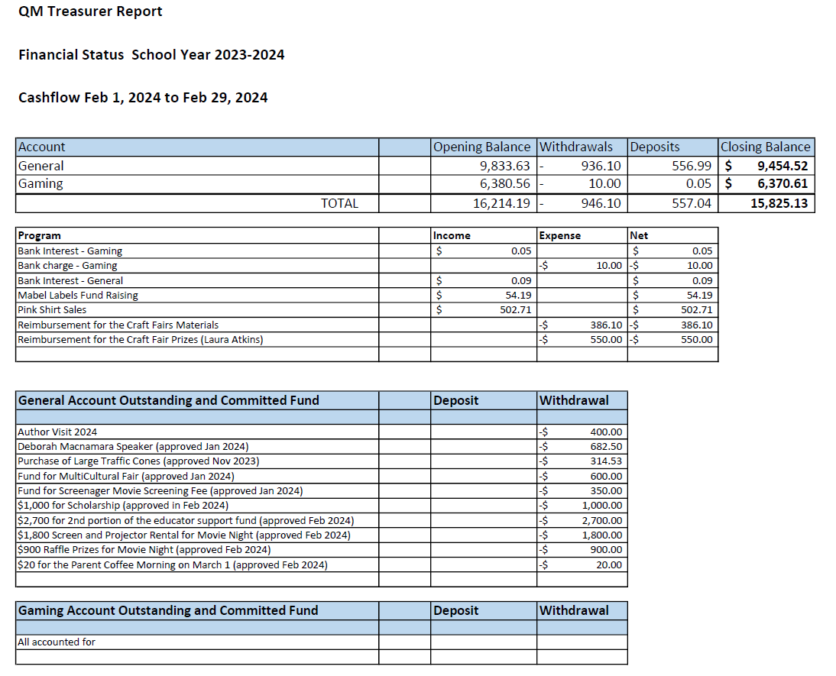
  - Committed funds: a lot of committed funds
      - Goal: need to make more money
      - PAC executive has approved on March 5: $ 200 for popsicles for sports day from the Gaming account and up to $150 for food/supplies for parent coffee mornings from the general account

11. Principal’s Report
- Basketball teams – lots of fun for the kids, kids really loved this activity. Had 2 boys teams and 1 girls team. Coaches were Mr.Klassen, Ms.Ping, Ms. Jessie and a parent
- Picture day – all done
- Vancouver Traffic
      - Elyssa met with Cameron Pearson and Liliana(city employees) as they had reached out to her because of the # of concerns they had received around the school area
      - Concerns: Deteriorating signage, poor signage, irresponsible parking behavior, Sasamat and 6th, the stop line is deteriorating,
      - Cameron wrote back as discussed, we will change the no parking sign to 3-minutes pick and drop-off sign, along the Trimble St.
      - No stopping anytime sign will be clarified
      - Along Trimble st all the way down to 4th, 3 minutes drop off sign will be in place
      - In terms of timeline, by the end of next school year, there is a long waiting list on the spot improvement list
      - In the future:
      - 1. Repaint the stop line at the Sasamat and 6th St.
      - 2. West 6th Avenue, will be reviewed in terms of volume of traffic, signage, in order to propose further changes
- Car Accident event:
March 1st, 2024, car accident: staff car was backed into, a big dent, no notes left to contact
- Heidi asking: giant cone idea
      - Elyssa: The city discourages using the cones to help with the traffic condition, it could lead to projectile hazard
- Heidi: feels passionate about having parent crossing guards again, mentioned multiple times encountered dangerous traffic behavior along 5th and Trimble St.
      - Elyssa: maybe create a timetable to see how to start the parents traffic control
- Westside Wrestling club
      - Started Monday
      - The club is volunteering their time
      - offered to support teachers with skills and movement, wrestling ideas, playing safely and staying strong
      - Only cost to the school is to borrow the wrestling mats from high school
- Fish on the fence
- Community school team offered after-school programs
- Happy Feet
- Looking at offering Basketball for older grades in the spring
- Received a Community link grant – target funds $1400.00
Applying funds for students specifically needs extra funds to support their after-school programs

12. Teacher Representative Report
Michelle: grade 2 and 3 teachers, worked on social studies, importance of Salmon for first nation culture, information research, non-fiction text features, dissection work shop of Salmon, students like it, with lots of interest

Nozomi Senga: Grade 2 teacher
1. Kindergarten, Grade 1 and Grade 1-2 did a Granville Island field trip, took public transportation
2. Seymour field trip, looking for signs of aquatic life

13. DPAC meeting summary (Natalia Kravchenko)
Facilities Planning Working Groups: facilities resolutions
Health and Safety Work Groups: current focus on IAQ
Food Framework Work Groups: food security programs
Inclusive Education WG (and EA Subcommittee): insufficient staffing at schools
Active Transportation Safe Routes WG: incident near Lord Byng, Lord Byng formed a transportation committee, exploring possibilities to make rules safer, not just
Music Work Group
Transparent enrolment projections and open data
Building for Current and Future Students
(wording corrected on Feb. 29th)
Update the Seismic Mitigation Program Timeline
Modernizing School Operating Capacity
Space
Lord Byng is over capacity (1200->1400 students)
Byng Arts Socials and English courses (cohorts) will not run net year
Other mini school are experiencing similar situation
VSB is aware of the growing number of students, which create new consideration for the budget
Real BC budget per student will be lower
There is a need to advocate for funding. Conversation about whether and how PAC budgets information could be shared with VSB

Proposing: We can invite a Facilities Planning WG representative to our PAC meeting to discuss in more details

DPAC openings:
1. Treasurer
2. Secretary

14. Scholarship Committee
Applications are now open
- Applications and info are on our PAC website and sent to 11 high schools (1 more pending)
- Deadline is 3:30pm on May 3
- June 3 successful applicant announced

15. Parent Coffee morning coordinator Report
- 1st parent coffee morning March 12, 2024
- next coffee morning April 18th, 2024

- Game and Moving night Coordinator report
Thursday May 9
Games, raffle, movie
Will need lots of volunteers

17. Direct Drive Coordinators Report
- Fish on Fences April 9-12. funds from Direct Drive
- Will be a renewed campaign for school technology likely starting in April – Amber and Jasmine will be in charge of this event

18. Old Business items
1. Queen Alexandra School Donation
- tabled from the last meeting
- will wait until after the Games and Movie Night to decide on the donation
- will discuss this in May

2. Screenagers Documentary
- PAC has approved $ to show this documentary once
From a parenting perspective, interest in navigating cell phone use
In January, Premier Eby announced that school districts in BC need to restrict cell phone use in the classroom by September
Cost of a single screening is $700 USD – in Janurary PAC approved spending $350 towards this; a family generously wanted to contribute the difference
Since then, interest in having multiple screenings over the year
- cost is $950 USD FOR A 1 year ( $1250 CAD)
- Family would contribute $500.00; PAC already contributed $350
- $450 needed to cover the difference
Discussion:
Heidi asked: Did we find out the answer about upgrading to a license if we purchase the one-time screening? Sandra: Yes - we get an one-time license and if we decide later to have a license it will cost , $250 USD to upgrade Some attendees liked this option
Michelle: would it be in multiple languages?Sandra: not sure, could ask about it
Michelle: maybe charging parents for the movie, so the parents could access it

Ms.Derban: if there is a way to put in some structures, that would make it equitable, one year of licence will allow for multiple screening opportunities

Since has heard from a few people that they would prefer the upgrade option, but hadn’t heard from everyone, Sandra asked if anyone wanted to put forward the following motion:
Motion to approve $450 towards a license for the Screenagers documentary from the general account
However, no one put forward the motion
Decision: we will go with the single screening license at this moment, we can have a revisit to this afterwards

19. New Business

- Fish on the Fences Program
Program is coming to QM April 9-12 for all grades
Funding from donations to Direct Drive
April 9-11 Each class receives a 45 minutes education session where they will learn about the local watershed and how to prevent pollution, what it means to be a steward, salmon and other local fish. This will be followed by a session where each student and staff paints a wooden fish
April 12: need 6-8 parents volunteers to install the fish on the fence, needs 4-6 hours, but likely to finish around noon

- Library Fundraiser
PAC would like to help the library purchase new books
Idea is to have an online book registry at a local bookstore where parents/families can purchase a book that is on the library’s wishlist

Seeking 1-2 parents to coordinate this event
Wishlist will come from Ms. Lam
Happening on April

- Teacher Appreciation Luncheon
Will be held on Wednesday, May 22
So far have one volunteer for decor, need 1 or 2 more volunteers to organize the food

- Mr. Weir Proposal
Mr. Weir is retiring in June. He is working on a proposal to apply for ArtStarts for a grant to be an artist-in-the-classroom at Queen Mary for next year. Project proposal called: “Building Community and Leadership in Music”. The idea of the proposal is to help building community and student leadership
- He could provide approx.. 70 hours of sing along time
- workshops and presentations will have students standing in front of the class/gym leading the movement and dance. These leaders are very often in grade 6 and 7
- Could help with the music at important assemblies such as Remembrance Day and Orange Shirt Day or even Friday Fitness
The ArtStarts grant
- He is applying for a $3500 grant
- Application requires 30% of funding to be covered from another source such as PAC
Mr.Weir is wondering if PAC could help support him with $1500
- This could come from gaming grant?
- We have $3510.61 in gaming grant
- His project proposal needs to be approved by the school still, however, due to the grant application due in May, it would be helpful for us to decide whether we can support him at today’s meeting

Motion to approve $1500 from the gaming account towards Mr. Weir’s ArtStarts grant application on the condition it is supported by the school
- ^{Motion} Heidi
- 2nd Erin Schwabe-Fry
Motion is carried.

20. Questions/Comments from attendees:
Valentina Lurye: nutrition for kids, ideas for having snacks at school, how to equip kids with better snack and lunch options, providing educational sessions for kids/parents
Health diet session from other PAC education nights
2023 we had a nutritionist came, gave out education session and healthy snack options
Ms.Derban: emphasized on healthy food chocies, past educational session, no food sharing rule, and family values on food sharing
- Sandra to discuss with Valentina the possibility of having a

21. Next PAC meeting: April. Date to be determined

